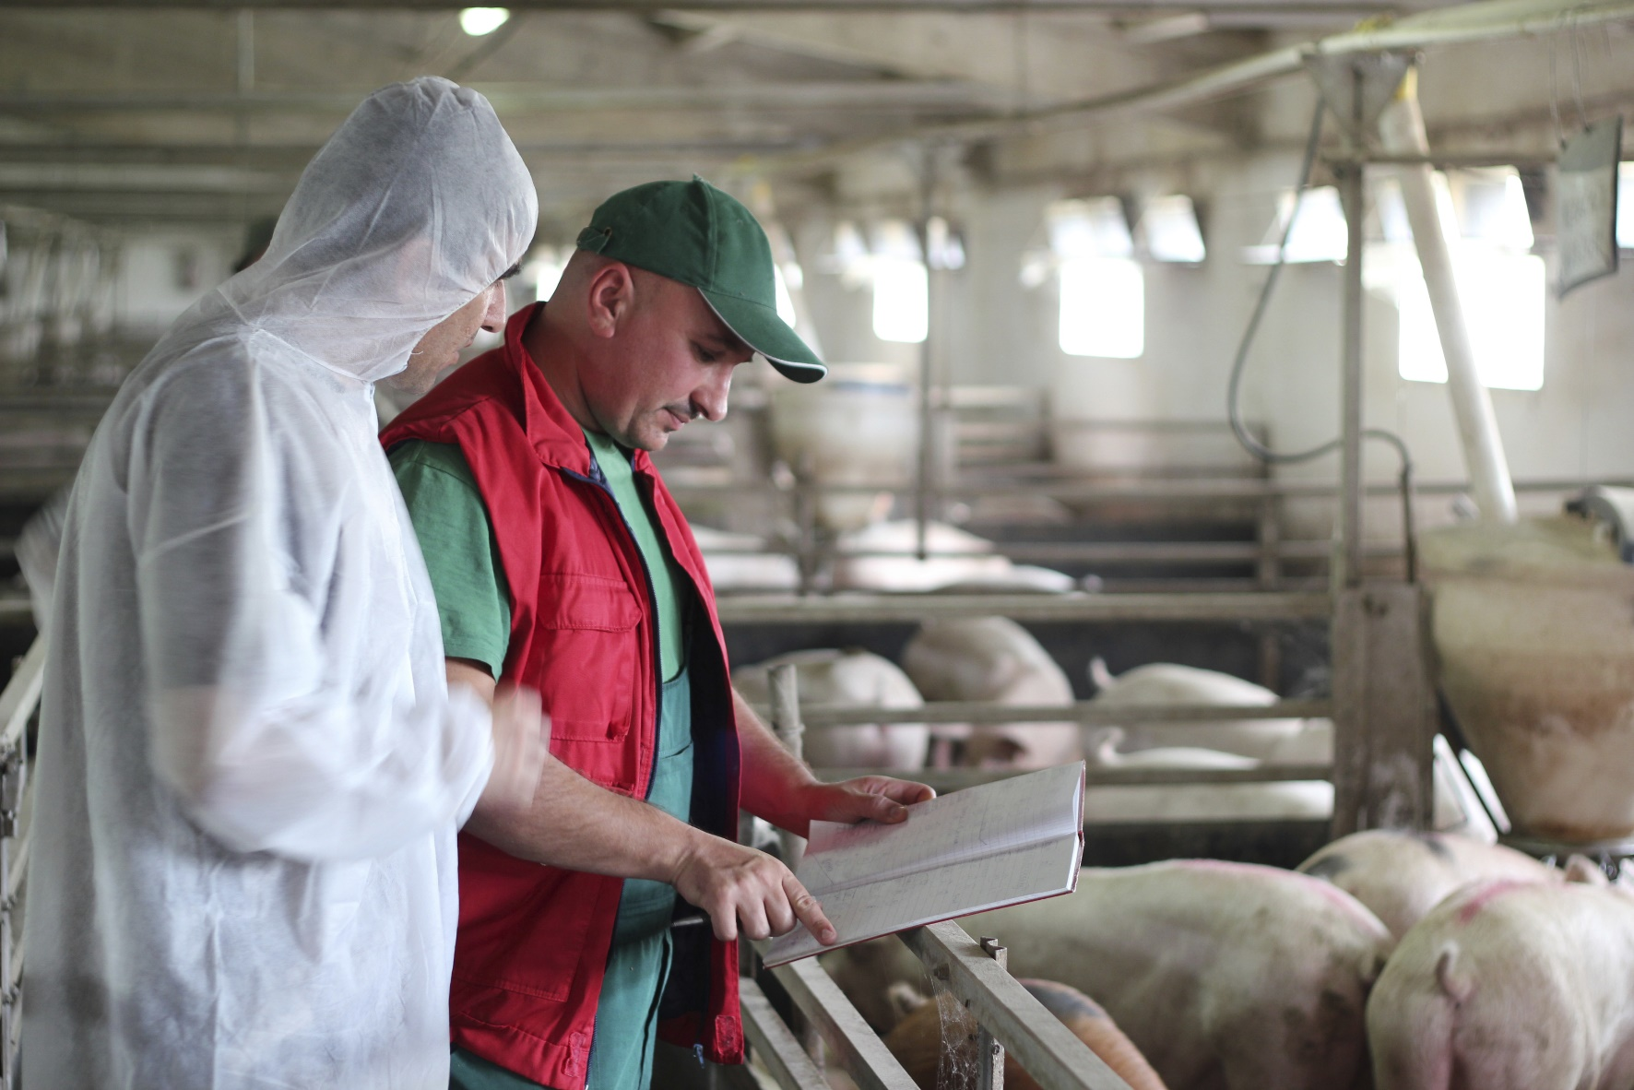

**Swine veterinarians work with farmers to make sure that pigs stay healthy! When a pig does get sick or injured, a swine veterinarian can help them feel better. Swine veterinarians use science to take the best possible care of the pigs. They also have to use math to calculate the amount of medicine an animal needs, for example. They know that healthy animals make healthy food.**

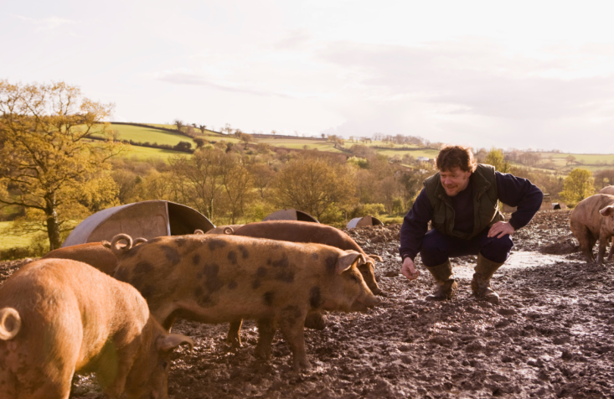

**Swine nutritionists use science to make sure that pigs of all different ages are getting the food they need to grow. There are many options for feedstuffs that a hog can eat, including corn, soybeans, and vitamin supplements. I help farmers decide how much of each feed component hogs need, and make sure that we are using the best feedstuffs to do so. By making sure that pigs are getting all their nutrients, swine nutritionists help pigs grow to be healthy and produce healthy pork for consumers!**

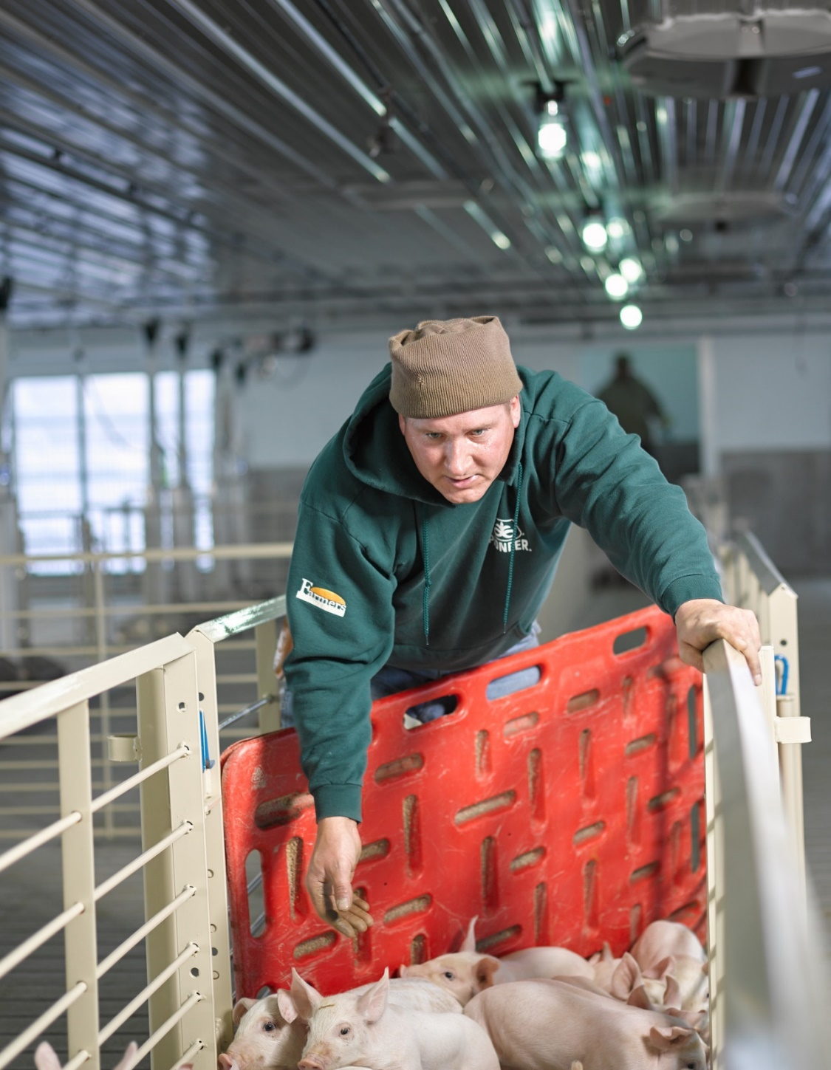

**I’m a hog farmer, and I use science and technology to feed and care for my hogs. I use math to make sure my hogs are getting the right amount of food and gaining enough weight. I rely on the nutritionist and veterinarian to help me take the best care of my hogs! I have to know everything about the animals that I raise to know when they are sick. Math is an important skill for me, because it helps me calculate my budget for the year and know when and where to market my animals.**

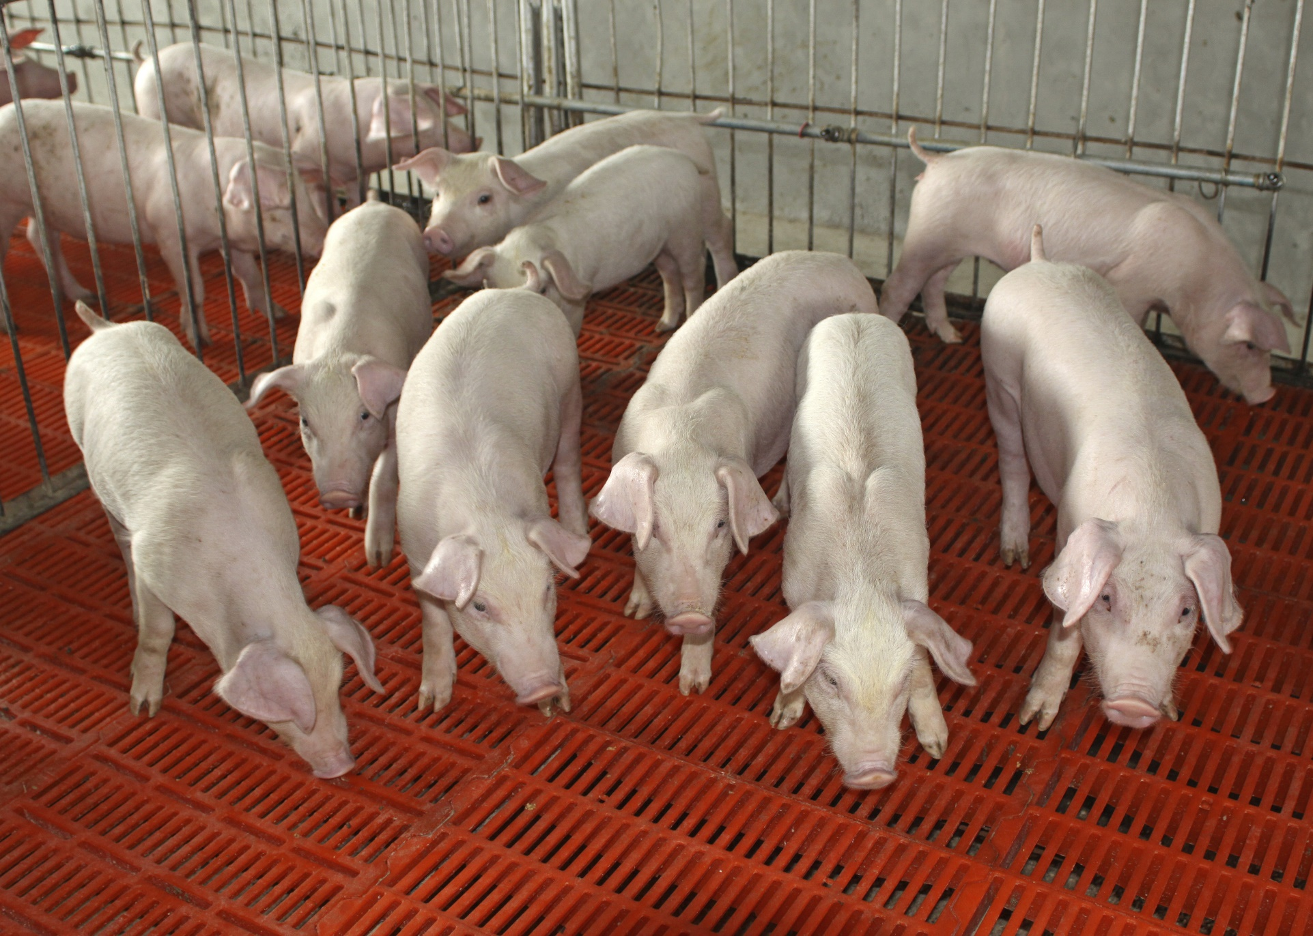

**Agricultural engineers also play a big role in raising hogs. Without them, hogs would have no barns to live in, and it would be hard to get their food to them! These engineers have designed special scales to weigh out the feed that every pig needs. Agriculture engineers also design and build the tractors and trucks used to plant, harvest, and move the feed to the pigs.**